# **CHAPTER 7: Recommendations for foraging fields**

**Recommendations for creating and maintaining foraging fields for the**

**European turtle dove, based on research carried out in Zeeland (2021-2023)**

**Foraging fields as a field measure**

The foraging fields tried and tested during this project all performed differently due to a range of factors including, but not limited to, past land use, crops grown in previous years, soil type, weather following sowing, and appropriate and timely field management. The findings of this study can serve as guidelines for creating best practice foraging fields, or as a starting point for future efforts to create foraging opportunities for turtle doves.

Each field should be evaluated individually when developing a management plan. To increase the chances of success, landowners should be well acquainted with the needs of the turtle dove and the characteristics of suitable foraging habitats. This will help them make independent decisions regarding the timing of management. Regular (external) assessments, approximately every four to six weeks, from April to July, would help ensure that management efforts are aligned with turtle dove needs.

Efforts to investigate alternative turtle dove foraging opportunities and locations, outside of the agricultural setting, can be guided by the land use preferences tagged doves have shown during this research. For example, their constant presence at campsites, make it worth investigating the feasibility of foraging strips, or similar, at these locations

*Disclaimer*

*The advice provided here regarding the creation and management of bespoke ‘foraging fields’ for the European turtle dove is based on our current knowledge and expertise regarding the species, and on research that has been carried out in Zeeland the past years. However, it is important to note that our understanding of European turtle dove ecology is constantly evolving. Furthermore, the effectiveness of 'foraging fields' in turtle dove conservation has not yet been established.*

*Additionally, it is important to consider that the research this advice is based on has been carried out on Walcheren, Zeeland, an area dominated by heavy clay soils. Therefore, the applicability of these recommendations will likely vary, depending on the specific environmental conditions and soil types in other regions.*

**Site selection**

Foraging fields should be located 300 m from existing turtle dove territories (Operation Turtle Dove, UK) or else within 300 m from suitable nesting habitat and a source of water.

**Seed mix and sowing**

Recommended species: corn spurrey, black medick, lesser trefoil, miner’s lettuce, field pansy

The final seed mix tested on this project was as follows (percentage weight). A simpler mix of just 4 or 5 species could be just as suitable and needs further testing.

|  |  |  |  |  |  |  |  |
| --- | --- | --- | --- | --- | --- | --- | --- |
| Red Clover Pastor | 2% |  | Common Vetch | 5% |  | Long-headed Poppy | 10% |
| White Clover | 3% |  | Narbonne Vetch | 5% |  | Miner’s Lettuce | 15% |
| Common Bird’s-foot | 5% |  | Spurrey | 10% |  | Cornflower | 5% |
| Black Medick | 15% |  | Camelina | 5% |  | Field Pansy | 5% |
| Lesser Trefoil | 5% |  | Buckwheat | 10% |  |  |  |

Sowing density: 5 kg/ha

Sowing moment: Autumn

Sowing method: Before sowing, create a false seedbed to reduce problematic weeds.

Sow 3 rows (50 cm apart), followed by a 2 m wide unsown (see figure)

Resowing is required every 2 years

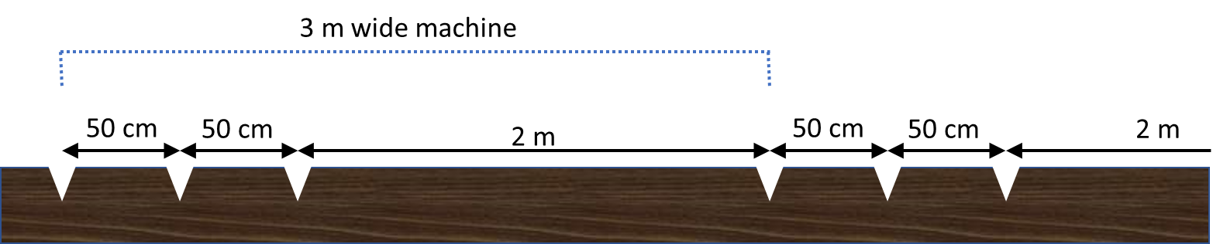

**Management**

Regular, timely management is needed to maintain an open and sparse foraging habitat through the growing season. When harrowing and hoeing are used, management will be needed every 4 – 6 weeks (see figure for suggested timing).

Each management round is carried out in a different direction. This ensures that vegetation does not become too dense or tall, sufficient bare ground is available, and seed from either the sown mix or from spontaneous weeds has time to develop and ripen.

|  |  |  |  |  |  |  |  |  |  |  |  |  |  |  |  |  |
| --- | --- | --- | --- | --- | --- | --- | --- | --- | --- | --- | --- | --- | --- | --- | --- | --- |
|  | **April** | | **May** | | | | **June** | | | | **July** | | | | **Aug** | |
| **Week** | **16** | **17** | **18** | **19** | **20** | **21** | **22** | **23** | **24** | **25** | **26** | **27** | **28** | **29** | **30** | **31** |
| **Management round** | **Round 1** | | | | **Round 2** | | | | | **Round 3** | | | | | **Round 4/ End** | |

**Round 1**

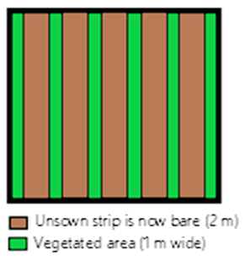

Unsown strip is now bare (2 m)

Vegetated area is 1 m wide

**Round 1**

When: Late April/early May

Aim: Create 60% bare ground in strips

How: EITHER Hoeing between sown rows (applicable only during first growing season when rows are visible) .

OR Hoeing or shallow power harrowing unsown strips (5 cm depth) of 2 m wide, and leaving a vegetated strip of 1 m wide.

**Rounds 2 - 4**

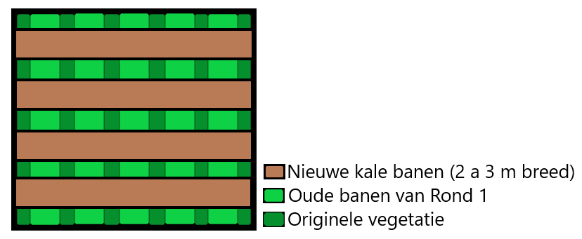

New bare strips 2-3m wide

Old strips from round 1

Original vegetation

**Round 2**

When: Every 4 – 6 weeks

Aim: Create 60% bare ground in strips

How: Each round harrows a different direction.

Hoeing or shallow power harrowing 2 – 3 m wide strips, leaving a vegetated strip of 1 m wide.

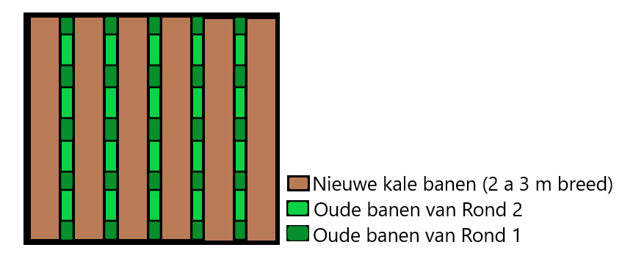

New bare strips 2-3m wide

Old strips round 2

Old strips round 1



**Round 3**

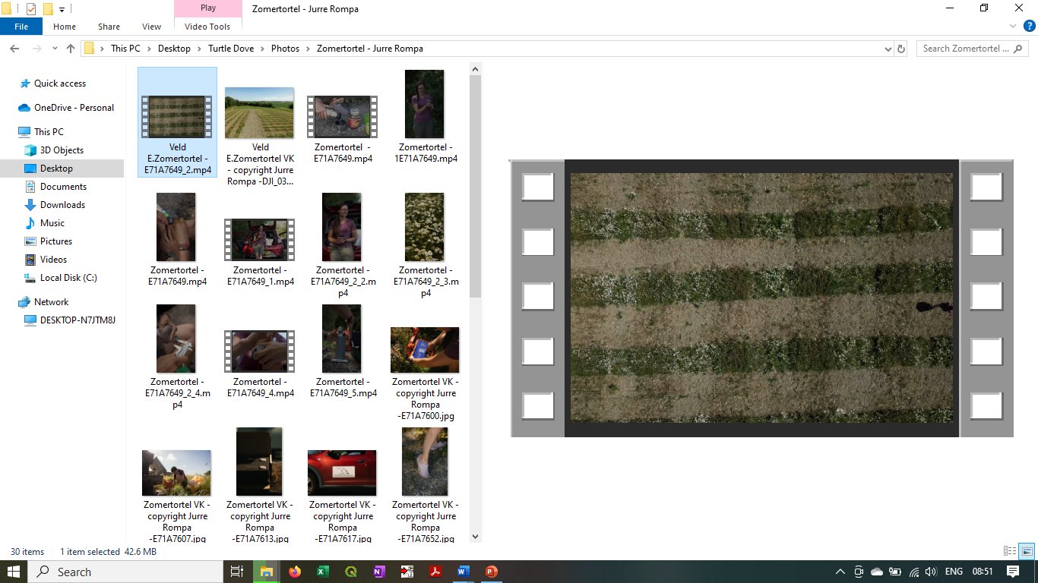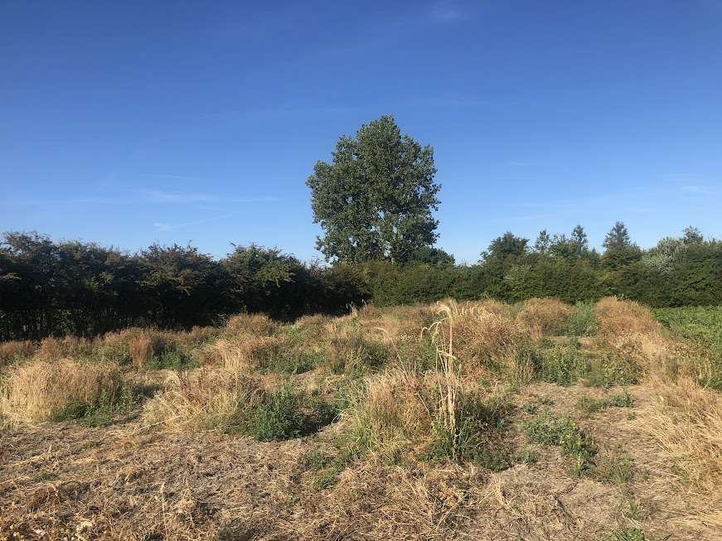

Photos: How vegetation should look after 3 or 4 management rounds. There should be squares of vegetation at different heights and flowering stages, alongside the newly harrowed bare strips.

**Management Round (final)**

When: From early August

Aim: Create 60 – 90 % bare ground

How: EITHER create more bare strips when needed until the end of September, then leave the field vegetated through the winter,

OR mow the entire field so it appears ‘harvested’. Leave it as stubble through the winter*.

*This was done on test plots during the project, however there is no evidence to determine whether this was beneficial or not. At this time of year, once harvested cropped fields such as flower seed and wheat became available, these land uses provided popular foraging sites for the tagged doves.

**Notes)**

To ensure landowners are knowledgeable of the needs of turtle doves, it would also be beneficial to meet with landowners, prior to setting up a foraging field. This would provide a chance to explain the instructions, educate them on how to recognise and judge suitable habitat and answer any questions.

Some form of standardised reminders and regular plot assessment from a knowledgeable field ecologist would need to be incorporated into the plan.